2014 Annual Report

DENVER COUNTY COURT

The Court’s Mission is to..

Administer justice fairly, efficiently and effectively; Provide excellent customer service; and
Foster a positive environment where employees enjoy their work.

The work of the Court is diverse, challenging, and fascinating. Denver County Court lead the state in filings with 177,488. Approximately 60% of our work is traffic cases; 16% are civil cases; 14% are municipal offense violations; and 10% are criminal cases.

Significant Developments

• Self Help Center

• Recovery Court

• Strategic Plan

• New Judicial Officers

• Top 10 Website Winner

SELF HELP CENTER

The Court’s Self Help Center opened in January. 1,927 indi- viduals received assistance in 2014. Since opening, the Cen- ter was named “Best DIY Legal Resource” by Westword Mag- azine. The assistance sought by litigants was related to evic- tions (26%); small claims (22%); civil money cases (17%); pro- tection orders (12%); collection matters (9%); name changes (4%); and miscellaneous matters (10%).

In addition to providing valuable assistance to litigants, a major focus of the Self Help Center has been to connect with service providers in the Denver area. This included the Denver Public Library and Supreme Court Library. In September, the Court’s Self Help Coordinator co-taught a class at the Denver Public Library on accessing legal forms online. The Coordinator col- laborated with Colorado Legal Services, the Colorado Poverty Law Project, the Strum College of Law Civil Litigation Clinic, and a number of private firms, to create a list of, and conduct trainings for pro bono attorneys willing to represent tenants in
eviction cases.

“Our mission is at once the oldest and most basic of this country: To right wrongs, to do justice, to serve man.”

Lyndon Baines Johnson

1

RECOVERY COURT

The Recovery Court Program was inspired by Presiding Judge John Marcucci in an effort to stop the cycle of reoffending he ob- served in his many years on the Denver County Court bench. 300 individuals were identified as the top violators. A study conducted by the Crime Prevention and Control Commission revealed the annual average number of days in jail for these individuals was
57, and the average number of visits to Denver Health was 16, for an annual cost of $8,036,388. 95% of these individuals are homeless, and many have drug or alcohol addictions and/or men- tal illness.

It was determined that this vulnerable population needed a com- prehensive response from the criminal justice system in order to make a difference. The comprehensive response involves identi- fying eligible program participants upon arrest; initiating benefit acquisition and conducting assessments while still in-custody; and offering the Recovery Court Program. The Recovery Court Pro- gram provides increased accountability; oversight by a case man- ager; housing; intensive behavioral health and trauma care; physi- cal health care; peer support; rewards and sanctions.

A team of people from across the criminal justice system spent many hours developing Recovery Court, and in April the program began. In 2014, the program had 40 participates and the docket was presided over by Judge James Breese. Every week a review team meets to discuss the progress of participants. The review team consists of the Judge, Program Coordinator Shari Lewinski, a CPCC representative, treatment providers, city attorney, public defender, and case managers.

The weekly attendance of the participants has been very good. The failure to appear rate for these individuals dropped from 44% to 7% since beginning the program. Six months prior to entering the program, these 40 individuals had 95 arrests and spent 1,932 days in jail. Six months after entering the program, these 40 indi- viduals have had 49 arrests and spent 546 days in jail. The pro- gram is making a difference and the team recently won the Mayor’s 5281 Award for their hard work.

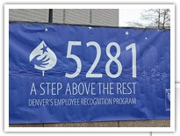

“All citizens are equal before the law. The humblest is the peer to the most powerful.” John Marshall Harlan

STRATEGIC PLAN

The Court’s first Strategic Plan was developed. The Plan’s primary focus is on six goals:

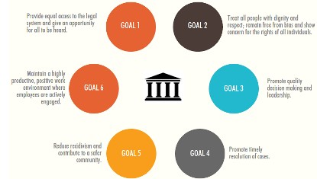

Numerous metrics were developed to monitor the court’s per- formance in these six goal areas. Strategies for improve- ment were developed and four priorities were identified for the upcoming year which include communication, employee engagement, efficiency, and training. The managers and su- pervisors formed 4 committees to address these priorities, and the Employee Advisory Committee was tasked with find- ing ways to create efficiency and reduce wait times of people
appearing in Court.

“Justice too long delayed is justice denied.”

Martin Luther King Jr.

NEW JUDICIAL OFFICERS

The Denver County Court bench is comprised of 17
Judges, three Magistrates and 11 part-time Magistrates.

In 2014, we said good-bye to four Judges who served Denver County Court for many years. These were Judge Raymond Satter, Judge Claudia Jordan, Judge Larry Bohning, and Judge Mary Celeste. We are grate- ful for their contributions to this Court and wish them well.

Four new Judges joined the bench and they are Judge Beth Faragher, Judge Theresa Spahn, Judge Olympia Fay and Judge Adam Espinosa.
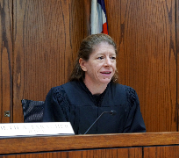
Judge Faragher received her Juris Doctorate degree from Case Western Reserve University in Cleveland, Ohio. Prior to being appointed to the bench, she was a Magistrate in Denver County Court, Pro Tem Judge for the City of Westminster, was in private practice, and served as a public defender.

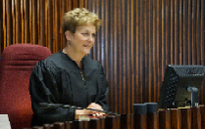

Judge Theresa Spahn received her Juris Doctorate de- gree from University of Denver, Sturm College of Law. Prior to being appointed to the bench, Judge Spahn was in private practice; she served as Director of the Sandra Day O’Connor Judicial Selection Initiative; was founding Executive Director of the Colorado Office of the Child’s Representative; a Domestic Relations Associate; a Dis- trict Court Magistrate; and a Deputy District Attorney in Adams and Mesa counties.

NEW JUDICIAL OFFICERS

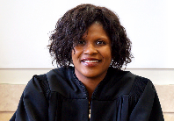

Judge Olympia Fay received her Juris Doctorate degree from University of Denver, Sturm College of Law. Prior to being appointed to the bench, Judge Fay was an As- sistant City Attorney with the Denver City Attorney’s Of- fice; a Deputy District Attorney in the 20th Judicial Dis- trict; and was a civil litigator in a private law firm special- izing in complex commercial litigation, securities litiga- tion, and intellectual property.

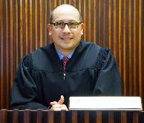

Judge Adam Espinosa received his Juris Doctorate de- gree from Washburn University. Prior to being appointed to the bench, Judge Espinosa served as senior trial at- torney for the Colorado Supreme Court Office of Attor- ney Regulation Counsel; a Deputy District Attorney in several Colorado counties; and is a frequent lecturer and author with the Colorado Bar Association, law school and other professional organizations.

WEBSITE AWARD

In July, Denver County Court was honored as having one of the top 10 Court Websites in the world. The Fo- rum on the Advancement of Court Technology (FACT) selected the honorees based on overall impression, in- teractive capabilities, accessibility, user interface, and access to public records. The other honorees were the Philadelphia Courts - First Judicial District of Pennsylva- nia; Connecticut Judicial Branch; Orange County Superi- or Court of California; Supreme Court of Nevada; Michi- gan Supreme Court; New Jersey Courts; Ashtabula County Court; Florida Office of the State Court Adminis- trator; and the United States Bankruptcy Court, Middle District of Florida.

In 2014, the Court’s Website saw a 25% increase in online transactions and a 35% increase in Website vis- its. The site had a total of 6,015,141 page hits; 74,366 payments; 1,229 warrant cancellations; 942 plea re- quests; and 356 transcript requests completed online in
2014. Since the site went live in March of 2013, it is es- timated that 28,000 less people had to come to the courthouse to complete their business.

Thanks to the hard working team that made this Website possible.

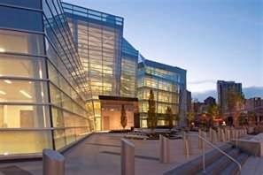

OTHER INTERESTING INFORMATION FROM 2014

• 171,633 cases reached disposition;

• 1,539 Final Hearings, 525 Court Trials, and 226 Jury Trials were held;

• The Court provided interpreters in 15,870 cases in 49 different languages;

• 111,562 calls were received in the Clerk’s Offices;

• 30,315 parking hearings were held and 99.5% of all written parking disputes were processed within 3 days of receipt;

• The Court’s case management systems were operational
99.9% of the time;

• 95% of all Traffic dispositions occurred within 90 days;

• 81% of all fines and fees imposed were collected;

• 100% of all restitution payments were forwarded to victims within 3 days;

• 68 individuals graduated from Sobriety Court and 10 graduat- ed from Court to Community. The recidivism rate for our prob- lem solving courts is consistently low and ranges from 4% to
8%;

• 17.5% decrease in jail days as a result of fewer probation rev- ocations;

• 100% of all eligible probation cases received an LSI assess- ment;

• 71% of all eligible traffic cases paid prior to their scheduled court date;

• 93% of all records requests were completed within 3 days;

• The dropped call rate in the Traffic/Civil Division decreased by
17%.

Thank-you to all employees of Denver County Court for their hard work, dedication, and excellent customer service!

