SAMHSXS REVISED ALCOHOL BIOMARKER ADVISORY- HOW IT EFFECTS YOUR COURT

By Paul Cary
n May 20, 2012, SAMHSA released a revised Advisory updating the treatment community on the important role of alcohol biomarkers. This is a much anticipated and welcomed document that examines

0
the recent scientific advances that have occurred since the original Advisory
(five years ago). NADCP commends SAMHSA for their efforts in bringing this most current information to substance abuse treatment professionals.

Here are the highlights related to EtG/EtS
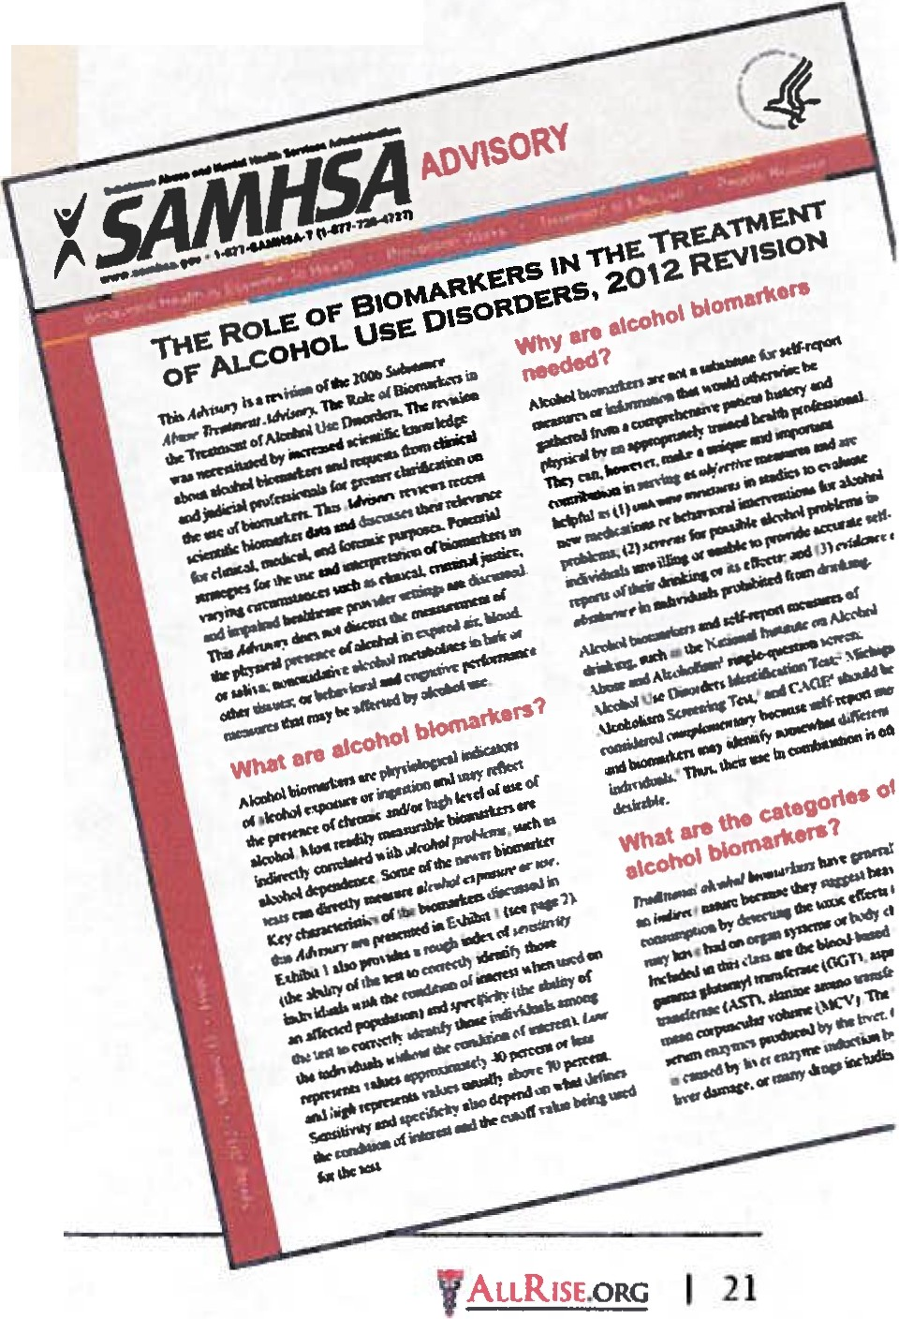

testing.

The new SAMHSA Advisory details that EtG/EtS can identify alcohol consump­ tion following "perhaps as li ttle as a single drink". The document also states that there is "probably little gender. age or ethnicity effect'' associa ted with EtG/EtS testing. In its "Windows of Assessment"
ex hibit , the revised Advisory provides
fu rther evidence that the EtG/Et S detec­ tion window has substantial advantages for determining alcohol relapse over other alcohol biomarkers.

In discussing cutoff concentrations, the Advisory relies heavily on a 2010 article Qadow & O'Malley) entitled "Clinical (non forensic) Application of EtG Mea­ surement" A summary of these authors EtG cutoff interpretations are as follows:
• A positive result using a 1000 nglmL EtG cutoff indicates "heavy drinking" during the prior 48 hours
• A positive result using a 500 - 1000 ngl mL EtG cutoff indicates prev10us heavy drinking (I - 3 days) or recent hght drinking (prior 24 hours) or recen t intense extraneous" exposu re (within
24 hou rs)
• A posi tive result using a 100 - 500 ngl mL EtG cutoff indic.nes previous heavy drinking (1 - 3 da ys) or previous light drinking (12 - 36 hours) or recent "extraneous" exposure

NADCP commends SAMHSA for their efforts in bringing this most current information to sub­ stance abuse treat­ ment professionals.

These consumption in terpretations are enti re!}' consistent with the con­ sensus EtG cutoff level currently used by most Drug Courts, DWI Courts and ot her treat ment cou rts (i e., 500 nglmL) There is no inconsistency be­
tween the revised Advisory and the use of the consensus 500 nglmL EtG cu toff in sanctioning proceedings based upon a "preponderance of the evidence" stan­
dard. Addi tionally, the admissibility of a sanction able posit1ve is f u rther enhanced when a court includes the testing of EtS and provides pamc1pan ts with an EtG/ EtS-speciflc client contract indicating what extraneous alcohol-containing products to avotd.
The document alerts programs to the potential of false positive EtG results when employing the immunoassay tech­ nique. Therefore, positive results from prelim inary screening tests should be confirmed prior to case adjudication (unless the client self-reports use). The document iden tifies LC/MS/MS and GCJ
MS as the reference confirmation methods.

The most significant table in the new SAMHSA Advisory is Exhibi t 3 shown on page 22.

NADCP :,-=.::

Exhibit 3. Summary Table of Alcohol Biomarkers by Particular Use
- - -
Biomarker |  | Screening for | Identify Relapse, | Time To Return | Monitoring
 |  | Heavy Drinking | Especially to Heavy | to Normal With | Abstinence
 | ' |  | Drinking | Abstinence
CDT |  | ./ | ./ | 2-3 weeks
EtG, EtS |  |  | ./ | 1-3 d(iY_S | ./
GGT |  | ./ |  | 2-4 weeks
MCV |  | ./ |  | Up to several months
PEth |  |  | ./ | 2-4 weeks
Sensor Device |  |  | ./ | Continual
SGOT/AST* |  | ./ |  | 2-4weeks
SGPT/ALT** |  | ./ |  | 2-4weeks
• Serum glutamic-oxaloacetic transaminase/aspartate transaminase
•• Serum glutamic pyruvic transaminase/alanine aminotransferas

EtG and EtS is the only biomarker recog­ nized as being appropriate for abstinence monitoring; based primarily on the time to return to normal levels following absti­ nence from alcohol.

For several years, NADCP has been pro­ moting "best practices" for EtG and EtS monitoring that includes the following components:
• providing participants an EtG/EtS­

EtG/EtS testing remains an accurate and reliable approach to alcohol abstinence monitoring that allows rapid therapeutic intervention to support recovery.

specific client contract designed to educate, alert and advise participants about commercially available products containing alcohol that have the poten­ tial to produce positive results if used
or consumed
• use of appropriate cutoff concentrations that largely negate the influence of ex­ traneous alcohol exposure on EtG/EtS results (consensus cutoffs: EtG - 500 nglmL. EtS- 100 nglmL)
• requiring confirmation of presump­ tively positive EtG screening result produced by preliminary immunoassay testing
• promoting the inclusion of EtS testing in relapse monitoring, due to its supe­ rior stability compared to EtG

Treatment Courts that have adopted these best practices represent models for the

use of EtG!EtS testing in a forensic con­
text, as illustrated by the growing body
of case law that supports this monitoring practice in a criminal justice environment.

This new advisory provides affirmation for the continued utilization of EtG/EtS testing as an effective treatment tool. That said, this document w1lllikely not pro­ voke significant changes in t he practices or polices of many treatment courts.

Two questions remain paramount to court programs. Is a posi tive urine EtG/ EtS test result a defini tive indicator of re­ lapse or prohibited drinking? Is a positive urine EtG!EtS test result sufficiem justi­ fication for client sanctiomng? While the new SAMHSA Advisory does not address these specific questions, it does pro\ide underlining support for curre nt court
policies if the best practices are followed.

EtG/EtS testing remains an accurate and reliable approach to alcohol abstinence monitoring that allows rapid therapeutic intervention to support recovery

The entire Advisory can be downloaded as a pdf from: http://kap.samhsa.gov/products/manuals/ advisory/pdfs/Advisory_Biomarkers_Re­ vision.pdf

22 I ALL RISE The Magw:mc of the Nclllonal Associlllion of Drug Court Professional s

