Denver County Court
City and County Building
1437 Bannock St., #108
Denver, CO 80202

Hon. Theresa A. Spahn
Presiding Judge

EXECUTIVE ORDER

Authority to Administratively Dismiss Cases Filed
Where Case Filed Has Impossible Date for Court Appearance

Recognizing that human errors may occasionally occur with the issuance of a summons and complaint and / or penalty assessment notice when written by officers or other authorized persons or entities and subsequently filed within the Denver County Court for Traffic, Criminal, General Sessions and / or General Violations matters; and also recognizing that both statute and ordinance have certain and specific legal requirements with respect to valid dates; and where these errors are on cases where such filings include an impossible date for an arraignment / first appearance date; this Executive Order authorizes and empowers any Deputy Clerk of the Denver County Court to enter such cases into the Court’s case management database and immediately and administratively dismiss the case(s) without prejudice, and to close the case(s) in their entirety.

This order is subject to the strict adhesion to the following rules designating an impossible court dates:

Part I – Application:
- This order is specific to only arraignment / first appearance Court dates;
- This order excludes Civil cases;
- This order excludes Parking matters;
- This order is effective as of: July 1st, 2018

Part II – Specificity:
For an arraignment / first appearance date, an impossible court date is defined as follows:
- Arraignment / first appearance date is non-existent in the current calendar year (e.g. February 29, 20xx, in a non-leap year);
- Arraignment / first appearance date is fictitious and does not exist in any year (e.g. April 32, 20xx);
- Arraignment / first appearance date exists in the past (e.g. April 8, 1966);
- Case filed after an arraignment / first appearance date has passed;
- Arraignment / first appearance date is blank;
- Arraignment / first appearance date is the same as the violation date.

Part III – Exclusions:
Dates which are not considered impossible court dates and must still be entered and set before the Court in the usual manner include the following:

- Arraignment / first appearance date is on a Saturday, Sunday, Legal/Court Holiday. These cases must be set on the next business day pursuant to rule/statute/ordinance;
- Violation date is significantly before a valid arraignment date are ripe to appear before the Court (e.g. violations for leaving the scene of an accident [hit and run] where violation date is 1-year before arraignment date);
- Clerks are specifically prohibited from treating any case as an impossible court date where the arraignment date is less than or greater than the statutory or ordinance requirements for an arraignment / first appearance date. These cases remain ripe to appear before the Court and are issues to be raised, contested or waived by the prosecution or defense. (e.g. ordinance requires arraignment set no less than 30 and no more than 90 days).

# # #

BY THE COURT:
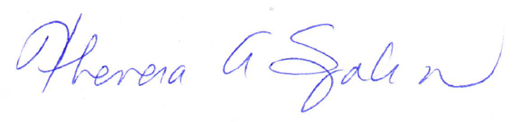

_________________________________
Hon. Theresa A. Spahn
Presiding Judge, Denver County Court

