Denver County Sobriety Court
Participant Handbook

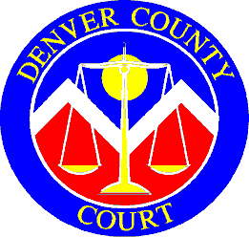

Mission Statement:
Provide an effective, efficient, judicially supervised, accountable, and systemic process to address addiction, offender success and recovery.

Contents
Welcome 3
What is Sobriety Court? 4
Program Rules 5
Fines and Costs 8
Treatment 9
Testing 9
Reviews 11
Proximal and Distal Goals 11
Incentives and Sanctions 12
Confidentiality 13
Phases 14
Graduation 19
Support Groups 20
Important Phone Numbers and Community Resources 21
Conclusion 22
Phase Applications 23

A Letter from Magistrate Melissa Annis and the Sobriety Court Team

Welcome to the Denver County Sobriety Court! This handbook is designed to answer your questions, set expectations, and provide information about the Sobriety Court program. As a participant in Sobriety Court, you will be expected to know and follow the rules and conditions of the Sobriety Court program. The information in this handbook should help you understand these rules and conditions.

You will be successful in this program if you follow three simple rules:

1. Be Honest: We can work through almost any problem together if you are truthful with us. You will not succeed in this program if you are dishonest with us, yourself or your family.

2. Show Up: Respect the time of those who are trying to help you. If you are late to appointments, treatment and Court hearings, it is a signal that you are not serious about this program.

3. Accept Responsibility: You are in this program due to your own actions. Take responsibility for what you have done and what you need to do. We will help you; however, sobriety is hard to achieve, especially when you don’t want it for yourself.

This program was created to give you an opportunity to seriously address problems with alcohol and drugs and recover from substance use issues. By choosing to enter Sobriety Court, you are choosing perhaps the best opportunity you will ever have to reclaim and rebuild your life.

The program is not easy. There are far greater expectations on you than if you were on regular probation.

Please read this handbook carefully. It is your responsibility to be familiar with its contents. We encourage you to share this information with your family and friends who support your recovery. The information in this handbook may change, without prior notice, and should not be considered a binding agreement between you and the Sobriety Court program.

CONGRATULATIONS on your decision to join Denver’s Sobriety Court program.

What is Sobriety Court?
Sobriety Court is a special, misdemeanor, treatment court in Denver County. It was developed to reduce the recidivism of drunk driving in the City and County of Denver. The program is voluntary, and eligibility is based on legal and clinical screening. It consists of five phases and is approximately 14-24 months in length.

Denver County Sobriety Court is designed for adults who need a structured, intensive program, and have a willingness to receive treatment for their substance use. Participants receive a team approach in which the Sobriety Court judge, probation officers, prosecution, defense counsel, and treatment providers work together. As a team Sobriety Court encourages you when you are doing well and offers support when you are struggling.

Basic Rules of Sobriety Court
- Be honest with yourself and the Sobriety Court team.
- Complete all phases of the Sobriety Court program.
- Remain alcohol and substance free throughout the program.
- Submit to random alcohol and/or drug screening.
- Participate in treatment as determined by treatment assessment.
- Report for all scheduled court reviews.
- Meet with probation officer as scheduled.

Program Rules
- Live in the Denver Metro area or within approximately 15 miles of the Lindsey-Flanigan Courthouse while supervised by Sobriety Court.

- Report to your Sobriety Court probation officer as directed. Comply with all conditions of probation. If unable to report as directed, contact your probation officer immediately.

- Participate in a full assessment, including an alcohol and drug evaluation, and attend, participate in, and complete treatment as assessed by treatment provider. Sign an Authorization to Share Information authorizing the Sobriety Court team to obtain information regarding compliance with treatment plan and monitored sobriety. The treatment plan may be modified by the treatment provider and/or the Sobriety Court team as circumstances arise and the treatment modifications must be complied by. Participate in reassessment by the treatment agency during the Sobriety Court program and complete additional treatment based upon this new assessment. Be responsible for any costs resulting from that treatment.

- Treatment includes the DUI Track, cognitive behavioral therapies, self-improvement, relapse prevention classes, mental health, and any other treatment recommended based on assessment. Treatment may include individual as well as group sessions. The Sobriety Court probation officer’s approval must be obtained prior to changing treatment agencies or terminating treatment. If terminated from treatment by an agency, the Sobriety Court probation officer must be notified immediately.

- Be actively involved in treatment and strive to make personal progress while in treatment. Treatment must be a priority. Attend all treatment sessions. Missing treatment will likely result in a sanction.

- Participate in positive social or community support programs or activities (AA, 12-Step, SMART Recovery, Phoenix) while in Sobriety Court and share with the team.

- Submit to chemical screening and testing as ordered by the treatment agency, Sobriety Court probation officer, and the court. If tests are missed, delayed, refused, or diluted, it will be considered “invalid” and a sanction will be imposed. Tampering or trying in any way to hide drug or alcohol use will be responded to with sanctions or removal from Sobriety Court.

- Marijuana will not be used in any form or for any purpose while participating in this program. Use of marijuana with a license/registry card is NOT allowed in Sobriety Court.

- You must inform Sobriety Court of the types and dosages of prescribed medications you are taking, as some medications may not be acceptable for this program. It is your responsibility to get the proper documentation from the prescriber and provide it to the Sobriety Court probation officer. Prescribed medications shall not be misused.
- You will not drive a motor vehicle without a valid Colorado driver’s license, valid insurance, and the interlock device (if required by DMV) while on Sobriety Court probation. If you choose to drive without a valid Colorado license or insurance or without a required interlock device, you will receive sanctions which can include revocation and removal from the program.

- Scheduled and unscheduled home visits with a Sobriety Court probation officer and the Denver County Court Marshal will be performed. Random searches of person, vehicle, and residence at the request of the Sobriety Court probation officer with the assistance of Denver County Court Marshal may be performed.

- No use or possession, in home or vehicle, of alcohol or drugs, including but not limited to alcohol, controlled substances, or mind-altering substances.

- You are not permitted to possess a firearm, explosive, or other destructive device, or any other dangerous weapon while on Sobriety Court probation unless permission is obtained from the court.

- Permission must be granted from the Sobriety Court team to leave the State of Colorado. A travel permit must be obtained. Travel permits will be assessed and issued on a case-by-case basis.

- Disclose all police contacts and new charges to the Sobriety Court probation officer within 24 hours. Any new conviction may result in a sanction being imposed and/or revocation being filed and may be grounds for being removed from Sobriety Court.

- Participation in Sobriety Court involves a minimum time commitment of 14 months as detailed in the Phases. All phases must be completed prior to graduating from the program and then successfully terminating from probation.

Honesty
It is your responsibility to disclose any violation of the terms of probation to your treatment provider, probation officer, and the Sobriety Court team.

Honesty is a core component of Sobriety Court.

Not being honest does not help recovery and holds back progression through the program. Dishonesty of any form such as lying, tampering with, or trying to hide drug or alcohol use, presenting fake documents, etc. will be responded to with sanctions or removal from Sobriety Court.

Honesty is essential to successful participation in Sobriety Court.

In the Courtroom

Being on time is required. Court begins on Tuesday at 2:30 p.m. and Friday at 9:30 a.m.

- Please do not wear hats, sunglasses, clothes displaying offensive language or advertising drugs or alcohol in the courtroom.
- Please be quiet while waiting to be called to visit with the judge. It is important you and others can hear and are paying attention to the conversation between the judge and all participants.
- Please do not read or sleep in the courtroom.
- Please turn off your phone before entering the courtroom. Cell phone use can be distracting to the court and to other participants and is not allowed during court.

Fines and Costs
Fines and costs vary per individual. As part of the agreement to participate in Sobriety Court $200 is taken off the $600 DUI fine upon entry to Sobriety Court. As you progress through the phases and receive incentives, money is taken off the remaining fines and costs. Payments on the fines and costs are not expected to begin until Phase 2, so you can focus on treatment and the requirements of Sobriety Court.

You are required to pay for transportation to/from court and treatment, monitored sobriety and for all recommended treatment by your treatment provider. In Phase 2, you will create a budget with your probation officer to assist in developing a plan for Sobriety Court costs.

Treatment
Upon joining Sobriety Court, you will be given assessments that will determine the appropriate level of treatment and monitoring for your specific needs. Treatment and monitoring are court ordered conditions of your probation supervision. Treatment may include cognitive behavioral therapy, enhanced outpatient therapy, relapse prevention, aftercare groups, etc., in addition to the standard DUI treatment track.

You and your treatment provider will prepare an individualized treatment plan. The treatment plan is a problem-solving strategy to identify problems, create goals, and identify action plans. The recommendations are based on your individual circumstances. Not all participants will be required to complete the same type of treatment.

Remember your participation in treatment groups, education classes, and life transitions/job development is mandatory. This is part of your treatment plan and court contract. If you miss classes, it is your responsibility to call your probation officer and treatment provider ahead of time to let them know you will be absent. Missing appointments may result in a sanction from the court.

Testing
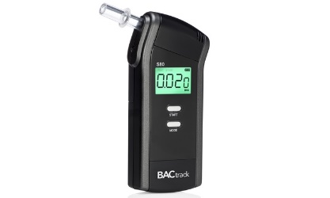
As a Sobriety Court participant, you will be required to submit to random alcohol and drug screening. Testing may be conducted by various methods; alcohol bracelet, in-home breathalyzer testing, breathalyzers, mouth swabs, urine tests, or hair follicle. Testing is random; it is important that you do not try to guess or predict when it may occur, but rather, be honest with yourself and comply with the testing requirements. In addition to your random alcohol/drug screening, you may be asked to submit an additional alcohol or drug screen, at any time, by the Sobriety Court judge, probation officer, or treatment provider.

Recent advances in the science of alcohol detection in urine have greatly increased the ability to detect even trace amounts of alcohol consumption. In addition, these tests are capable of detecting alcohol ingestion for significantly longer periods of time after a drinking episode. Because these tests are sensitive, in rare circumstances, exposure to non-beverage alcohol sources can result in detectible levels of alcohol. To preserve the integrity of the Sobriety Court testing program, it has become necessary to restrict and/or advise Sobriety Court participants regarding the use of certain alcohol containing products.

It is YOUR responsibility to limit your exposure to the products and substances detailed below that contain ethyl alcohol. It is YOUR responsibility to read product labels, to know what is contained in the products you use and consume and to stop and inspect these products BEFORE you use them. A positive result will be treated as a use.

The following is a list of SOME products which frequently contain alcohol. There are more items than listed below that contain alcohol and will affect drug/alcohol testing. Read labels before you use any product to ensure there is no alcohol in the product.

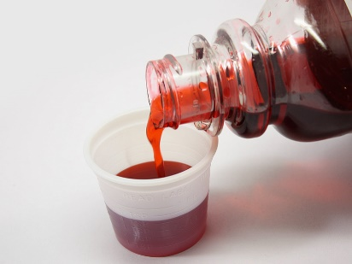
• Cough Syrups and Other Liquid Medications: Sobriety Court participants are prohibited from using alcohol-containing cough/cold syrups, such as Nyquil. You are required to read product labels carefully to determine if they contain ethyl alcohol (ethanol). All prescription and over-the-counter medications should be reviewed with your probation officer before use. Information on the composition of prescription medications should be available from your pharmacist. Non-alcohol containing cough and cold remedies are readily available at most pharmacies and retail stores.
• Non-Alcoholic Beer and Wine: Although legally considered non-alcoholic, NA beers do contain a residual amount of alcohol that may result in a positive test. Sobriety Court participants are NOT permitted to ingest NA beer or wine.
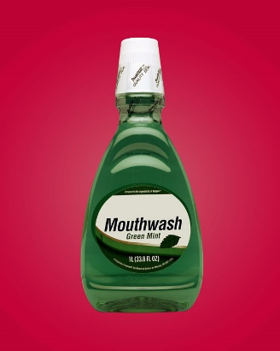
• Food and Other Ingestible Products: There are numerous other consumable products that could result in a positive test. Flavoring extracts, such as vanilla and almond extract, and liquid herbal extracts such as Gingko Biloba, could result in a positive screen for alcohol. Communion wine, food cooked with wine, and flambé dishes (cherries jubilee or baked Alaska) MUST be avoided. Read carefully the labels on any liquid herbal or homeopathic remedy. In addition, foods containing poppy seeds must not be consumed.
• Mouthwash and Breath Strips: Most mouth washes (Listermint, Cepacol, etc) and other breath cleansing products contain ethyl alcohol. The use of mouthwashes containing ethyl alcohol can produce a positive test. Non-alcohol mouthwashes are readily available.
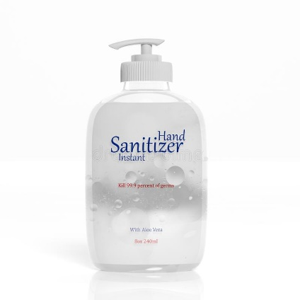
• Hand Sanitizers: Hand sanitizers and other antiseptic gels and foams used to disinfect hands contain up to 70% ethyl alcohol. Excessive, unnecessary or repeated use of these products could result in a positive test. Hand washing with soap and water is just as effective.

• Bug Spray: Certain bug sprays contain ethanol. Excessive, unnecessary or repeated use can result in a positive test. Bug sprays containing ethanol are not permitted.

Reviews
Sobriety Court relies on and emphasizes frequent judicial contact with each Sobriety Court participant. At each review hearing, the Sobriety Court judge is provided with a written or verbal report of your progress. You will have the opportunity to respond to the report and discuss with the court your accomplishments or concerns. At the review hearings, the judge may impose immediate sanctions for any non-compliance or offer incentives for compliance and sobriety. Reviews may be increased or decreased based on your compliance.

Proximal and Distal Goals
Sobriety Court uses the words “proximal” and “distal” when talking about goals. Proximal means a goal you have the knowledge and tools to achieve right now. For example, some proximal goals in Phase 1 are coming to all court dates, taking all UAs, being honest with the Sobriety Court team, and meeting with your probation officer. Distal means a goal for which you may need to learn new things, gain new tools, in order to achieve. Some examples of distal goals might be getting a job, going to school, or volunteering, abstinence from alcohol and drugs, or finding housing. As you move through the phases in Sobriety Court, you will learn new tools and behaviors to help make your distal goals proximal.

Incentives
Incentives are rewards for positive behavior and progress in the program. The reason for the incentive is discussed with each participant.

Incentives can include:
- Praise, encouragement, clapping
- Gift cards, Sporting and Special Event tickets
- Early call at review hearings
- Basket pulls – small gifts
- Money off fines and costs
- Decreased court appearances
- Hours off community service
- Travel

Sanctions
At the review hearings, the Sobriety Court judge considers any allegations of non-compliance that are presented by the team. The judge then selects an appropriate sanction based on the individual’s circumstances, the nature of the violation, and the history of compliance.

Possible sanctions that could be imposed:
- Reprimand or warning by the Judge
- Written assignments shared with the court
- Increased community service hours
- Increased reporting with probation officer
- Increased monitored sobriety
- Attendance at a Sobriety Court graduation
- Delay in phase change
- Saturday Work Program
- Jail
- Termination from the program
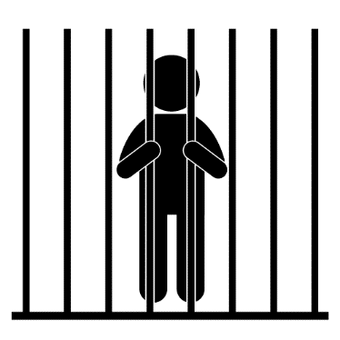

Confidentiality
Federal laws regarding confidentiality protect the records of all participants. We may not release written or verbal information without your written signed permission. If there is an emergency or legal circumstance, like those listed below, your permission to release information would not be required.
1. The disclosure is allowed by a court order.
2. The disclosure is made to medical personnel in a medical emergency, or to qualified personnel for audit or program evaluation.
3. You commit or threaten to commit a crime, either at the program or against any court staff person, team member, other program participant, or member of community.
4. You are suspected of child abuse.
5. You are threatening homicide or suicide.

Phases
Sobriety Court is a five-phase, highly structured program, lasting 14 to 24 months. Individual progress will vary. Each phase consists of specific requirements for advancement into the next phase. The final decision for advancement from each phase is determined by the Sobriety Court judge/team based on progress in treatment and achievement of phase goals.

Phase Requirements

The decision for phase advancement is made by the Sobriety Court Judge/Team based on progress in treatment and achievement of phase goals.

Incarceration Phase
- Comply with terms and conditions of incarceration

Phase 1: Intake and Orientation, 30 days
Assessment and Treatment
- Complete intake assessment with treatment and develop your treatment plan
- Attend and engage in treatment as designed

Supervision
    - Meet with probation officer within 1 business day upon release from jail
    - Make contact with probation officer between court dates
    - Home visit at probation officer’s discretion
    - Develop transportation plan

Monitored Sobriety
    - Comply with alcohol monitoring breathalyzer system as ordered (at least 30 days)
    - Submit random alcohol/drug screens (UAs) at a minimum of 3x per month

Court
  - Court reviews every other week

To move to Phase 2:
- Minimum 14 days sobriety (14 days in a row, post-incarceration, no missed, diluted, tampered, or positive UAs).
- Engaged with treatment.
- Compliant with court and probation.
- Completed transportation plan.
- Submitted Phase 2 application.

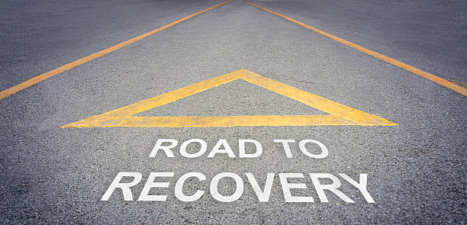
Phase 2: Active Treatment and Early Recovery, 90 days
Assessment and Treatment
  - Attend and participate in treatment plan

Positive Support Programs
  - Identify support in recovery community, write about the recovery support, and share with team
  - Identify pro-social activity in community and share with probation officer

Employment and Education
  - Maintain or actively look for job, training, or education

Supervision
  - Meet with probation officer every 3 weeks between court dates or as directed
  - Home visit at probation officer’s discretion
  - Create a budget and share with your probation officer

Monitored Sobriety
- Submit random alcohol/drug screens (UAs) a minimum of 3x per week

Court
  - Court reviews every 3 weeks or as directed
    - Make at least 1 payment toward fines and costs
    - Identify court-approved location for completion of community service (UPS) hours

To move to Phase 3:
- 30 days sobriety (30 days in a row with no missed, diluted, tampered, or positive UAs).
- Engaged with treatment.
- Outlined recovery support system and shared with the team.
- Identified pro-social activity to engage with in Phase 3.
- Maintained or actively looking for a job, training, or education.
- Compliant with court and probation.
- Submitted a budget.
- Made 1 payment toward fines and costs.
- Identified a court-approved location to complete community service (UPS).
- Submitted Phase 3 Application.

Phase 3: Sobriety and Stability, 120 days
Assessment and Treatment
- Attend and participate in treatment plan

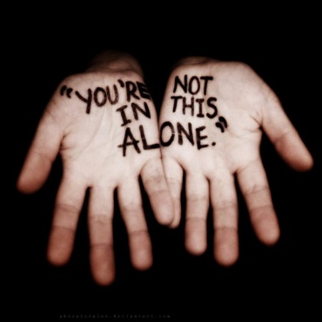
Positive Support Programs

- Participate in pro-social or community support programs and share in court

Employment and Education
  - Maintain or actively look for job, training, or education

Supervision
- Meet with probation officer every 4 weeks between court dates or as directed
- Home visit at probation officer’s discretion

Monitored Sobriety
    - Submit random alcohol/drug screens (UAs) a minimum of 3x per week

Court
- Court reviews every 4 weeks or as directed
- Make monthly payments on fines and court costs
- Begin required community service (UPS) hours. 24 hours UPS are needed to move to Phase 4

To move to Phase 4:
- 45 days sobriety (45 days in a row with no missed, diluted, tampered, or positive UAs).
- Engaged with treatment.
- Attended pro-social activity and shared with team.
- Maintained or actively looking for a job, training, or education.
- Compliant with court and probation.
- Made at least 3 monthly payments toward fines and costs.
- Completed 24 hours of community service (UPS).
- Submitted Phase 4 Application.

Phase 4: Growth and Sober Lifestyle, 120 days
Assessment and Treatment
- Continue with treatment plan
  - Create Relapse Prevention Plan and present to team

Positive Support Programs
- Participate in pro-social or community support programs and share in court

Employment and Education
  - Maintain or actively look for job, training, or education

Supervision
- Meet with probation officer 1x per month between court dates or as directed
- Home visit at probation officer’s discretion

Monitored Sobriety
    - Submit random alcohol/drug screens (UAs) a minimum of 2x per week

Court
- Court reviews 1x per month or as directed
- Complete the Victim Impact Panel (VIP)
- Make monthly payments on fines and court costs
- Continue working on required community service (UPS) hours. 24 hours of UPS must be completed in Phase 4 to move to Phase 5, for a total of 48 hours completed in the program so far

To move to Phase 5:
- 60 days sobriety (60 days in a row with no missed, diluted, tampered or positive UAs).
- Engaged with treatment.
- Completed Relapse Prevention Plan and shared with the team.
- Attended pro-social activity and shared with team.
- Maintained or actively looking for a job, training, or education.
- Compliant with court and probation.
- Attended the Victim Impact Panel.
- Made at least 8 monthly payments toward fines and costs. (1 was made in Phase 2, 3 were made in Phase 3, 4 made in Phase 4.)
- Completed 24 hours of community service (UPS), for a total of at least 48 hours completed.
- Submitted Phase 5 Application.
Phase 5: Graduation and Community Transition, 60 days
Assessment and Treatment
  - Continue with final phase of treatment plan
  - Develop an aftercare plan with treatment provider

Positive Support Programs
- Participate in pro-social or community support programs and share in court

Employment and Education
  - Maintain or actively look for job, training, or education

Supervision
- Meet with probation officer 1x between court dates or as directed
- Home visit at probation officer’s discretion

Monitored Sobriety
    - Submit random alcohol/drug screens (UAs) a minimum of 2x per week

Court
- Court reviews every 6 weeks or as directed
- Arrange a formal payment plan for remaining fines and court costs (monthly payments)
- Complete remaining UPS hours

To Graduate:
- 90 days sobriety (90 days in a row with no missed, diluted, tampered, or positives UAs).
- Engaged in treatment and completed an aftercare plan.
- Engaged in pro-social activities.
- Maintained or actively looking for a job, training, or education.
- Compliant with court and probation.
- Arranged a formal payment plan for remaining fines and court costs (monthly payments).
- Completed remaining community service (UPS) hours.
- Submitted a Graduation Application to the team describing accomplishments from Sobriety Court and goals for post-graduation.

Graduation
Once you successfully complete the requirements for Phase 5, you will be a candidate to graduate from the Sobriety Court program. You must submit a Graduation Application to the Sobriety Court Team to be considered for graduation. The final decision for graduation is determined by the Sobriety Court Judge.

Graduation from the Sobriety Court program is a very important event. Your family and friends will be invited to join you at a special ceremony to celebrate all that you have achieved and your goal to maintain an alcohol/drug-free life.

**The final decision for advancement from each phase and graduation is determined by the Sobriety Court judge.

Post-Graduation Supervision
Once you have graduated from Sobriety Court, you will be placed on unsupervised probation for the remainder of your probation term. You will be required to keep in communication with your Sobriety Court probation officer to report any changes in residence or phone numbers. You are also required to report any new charges or contact with the police. A criminal record check will be conducted prior to your end of probation date. If you receive any new charges you may be subject to a probation revocation being filed.

Support Groups
Involvement in support groups is required as part of your participation in Sobriety Court. Support groups are an important part of achieving and maintaining sobriety. If you are not already involved in a support group, we encourage you to contact one of the agencies listed.
Phoenix – Sober Active Community
https://thephoenix.org/
2233 Champa Street (720) 440-9175

SMART Recovery-Meetings, online community, training
www.smartrecovery.org

Heart of Recovery-Shambhala Meditation Center Denver
https://denver.shambhala.org/heartofrecovery/
303-369-2807

Alcoholics Anonymous (AA)
www.daccaa.org
(303) 322-4440

Marijuana Anonymous (MA)
http://marijuana-anonymous.org/find-a-meeting/

Narcotics Anonymous (NA)
www.nacolorado.org
(303) 832-3784

Cocaine Anonymous (CA)
www.cacolorado.org
(303) 421-5120

LifeRing Colorado (secular)
http://liferingcolorado.org
Email: liferingcolorado@gmail.com

CeDAR-UC Health Meetings Calendar
www.cedarcolorado.org/about-us/meetings/

Gay & Sober – Meetings
www.gayandsober.org/meeting-finder-colorado

Important Phone Numbers

UA Line – 303-515-7638

Denver County Court Probation – 720-913-8300
Esther Arrieta – 720-913-8347, Esther.arrieta@denvercountycourt.org
Melissa Bongiovanni – 720-913-8359, Melissa.bongiovanni@denvercountycourt.org
Salena Perez – 720-913-8367, Salena.perez@denvercountycourt.org

Office of the Colorado State Public Defender-Denver – 303-620-4999

Denver District Attorney’s Office – 720-913-9000

IDEA
Denver-303-477-8280
Aurora-720-949-0095
Brighton-303-659-9440
Thornton-303-996-9966

GEO
Denver-303-832-1144
Northglenn-303-457-9576

Mile High Behavioral Healthcare
Delaware St- 303-825-8113
Federal Blvd – 303-761-0200

Community Resources
Remerg – Information on housing, jobs, benefits. A re-entry guide.
www.remerg.com

Colorado Coalition for the Homeless
www.coloradocoalition.org
2111 Champa Street. (303) 293-2217

Veterans Administration
www.denver.va.gov
1055 Clermont Street (303) 399-8020

RTD Information
www.rtd-denver.com
(303) 299-6000

Stout Street Foundation
http://stoutstreet.org
(303) 321-2533

Conclusion
We hope this handbook has been helpful to you and has answered some of your questions. If you have any additional questions or concerns about the Sobriety Court program, please feel free to ask any of the Sobriety Court team members or discuss your questions with your attorney.

Sobriety Court exists to help you achieve total abstinence from alcohol, other drugs, and all criminal activity. The program is designed to promote self-sufficiency and to return you to the community as a productive and responsible member. It is your choice as to the progress you make. The Sobriety Court team is present to guide and assist you, but the final responsibility is yours. You must be motivated to make this change and commit to a law-abiding and alcohol and drug-free life.

We recognize participants in this program take on significant responsibility and challenge. The team thus congratulates you and appreciates you for your willingness to assume this responsibility. We have full confidence that with your commitment and hard work, you will establish yourself as a safe and sober driver, employee, family member, and citizen.

We are glad you are here and look forward to getting to know you and assisting you as you advance in the program. WELCOME.

Denver County Sobriety Court
Application for Phase 2

Name: Date Turned in:

Current Address: Phone:

Email:

To advance to Phase 2 you must have (place an “x” if task is complete):

- Been in Phase 1 for a minimum of 30 days. Date released from jail:

- Have a minimum of 14 days in a row of sobriety monitoring post-incarceration, with no missed, diluted, or tampered, or positive UAs. Date of last miss, dilute, tamper or positive UA?

- Engaged in treatment and attending regularly.
  - Counselor verification signature

- Compliant with probation supervision.
  - Probation verification signature

- Completed transportation plan and shared with team.

Do you have a valid Colorado Driver’s License? Yes No
If No, what do you need to do to get your license?

Please describe 3 of your accomplishments during incarceration and Phase 1.

Please provide 3 goals for Phase 2.

Denver County Sobriety Court
Application for Phase 3

Name: Date Turned in:

Current Address: Phone:

Email:

To advance to Phase 3 you must have (place an “x” if task is complete):

- Been in Phase 2 for a minimum of 90 days. Date entered Phase 2:

- Have a minimum of 30 days in a row of sobriety monitoring, with no missed, diluted, tampered, or positive UAs. Date of last miss, dilute, tamper or positive UA?

- Engaged in treatment and attending regularly.
  - Counselor verification signature

- Compliant with probation supervision.
  - Probation verification signature

- Be working, actively looking for work, or going to school.

- Identified court-approved location for community service. Location:

- Outlined recovery support system and shared with the team.

- Identified pro-social or community support program or activity to engage with in Phase 3.

  - Program or Activity:

- Submitted a budget.

- Made 1 payment toward fines and costs. Date of payment:

Do you have a valid Colorado Driver’s License? Yes No
If No, what do you need to do to get your license?

Please describe 3 of your accomplishments during Phase 2.

Please provide 3 goals for Phase 3.

Denver County Sobriety Court
Phase Application for Phase 4

Name: Date Turned in:

Current Address: Phone:

Email:

To advance to Phase 4 you must have (place an “x” if task is complete):

- Been in Phase 3 for a minimum of 120 days. Date entered Phase 3:

- Have a minimum of 45 days in a row of sobriety monitoring, with no missed, diluted, tampered, or positive UAs. Date of last miss, dilute, tamper or positive UA?

- Engaged in treatment and attending regularly.
  - Counselor verification signature

- Compliant with probation supervision.
  - Probation verification signature

- Be working, actively looking for work, or going to school.

- Completed 24 hours of community service (UPS). Location:

- Attended pro-social or community support program or activity.
  - Program or Activity:

- Made at least three monthly payments toward fines and costs.

Do you have a valid Colorado Driver’s License? Yes No
If No, what do you need to do to get your license?

How has your recovery support system changed since Phase 2?

Please describe 3 of your accomplishments during Phase 3.

Please provide 3 goals for Phase 4.

Denver County Sobriety Court
Phase Application for Phase 5

Name: Date Turned in:

Current Address: Phone:

Email:

To advance to Phase 5 you must have (place an “x” if task is complete):

- Been in Phase 4 for a minimum of 120 days. Date entered Phase 4:

- Have a minimum of 60 days in a row of sobriety monitoring, with no missed, diluted, tampered, or positive UAs. Date of last miss, dilute, tamper or positive UA?

- Engaged in treatment and attending regularly.
  - Counselor verification signature

- Compliant with probation supervision.
  - Probation verification signature

- Be working, actively looking for work, or going to school.

- Completed 24 hours of community service (UPS). Location:

- Attended pro-social or community support program or activity.
  - Program or Activity:

- Completed and shared Relapse Prevention Plan with team.

- Attended Victim Impact Panel (VIP). Date:

- Made at least eight monthly payments toward fines and costs. (1 was made in Phase 2, 3 were made in Phase 3, 4 made in Phase 4.)

Do you have a valid Colorado Driver’s License? Yes No
If No, what do you need to do to get your license?

Please describe 3 of your accomplishments during Phase 4.

Please provide 3 goals for Phase 5.

Denver County Sobriety Court
Graduation Application

Name: Date Turned in:

Current Address: Phone:

Email:

To Graduate you must have (place an “x” if task is complete):

- Been in Phase 5 for a minimum of 60 days. Date entered Phase 5:

- Have a minimum of 90 days in a row of sobriety monitoring, with no missed, diluted, tampered, or positive UAs. Date of last miss, dilute, tamper or positive UA?

- Engaged in treatment and attending regularly. Completed an aftercare plan.
  - Counselor verification signature

- Compliant with probation supervision.
  - Probation verification signature

- Be working, actively looking for work, or going to school.

- Completed all remaining hours of community service (UPS). Location:

- Attended pro-social or community support program or activity.
  - Program or Activity:

- Arranged a formal payment plan for remaining fines and court costs (monthly payments).

Do you have a valid Colorado Driver’s License? Yes No
If No, what do you need to do to get your license?

Please respond to the questions on the following pages. It is important that you make sure your answers are detailed. If you need additional space, you may add pages to this application. Please write the number of the question you are continuing.
Your application is to be submitted to your probation officer no less than two (2) weeks prior to your graduation date. Your probation officer will initially review your application. If after review, areas of the application require clarification, you may be asked to provide more information. Upon acceptance of the initial review, the application will be passed to the entire Sobriety Court team for approval.

1. What makes you a good candidate for Sobriety Court graduation?

2. Discuss your progress in Sobriety Court and what you have learned.

3. What are your plans to continue your success after Sobriety Court?

4. Discuss your aftercare plan and how it will help with your sustained sobriety.

5. Detail your sober support system. What interests and activities do you plan to add or continue in your life after you graduate from Sobriety Court?

6. If offered, would you be interested in a Sobriety Court alumni group? (Y/N)

